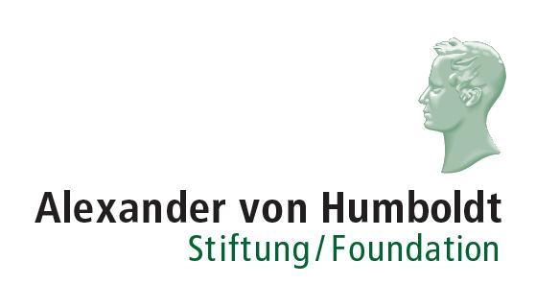

The Alexander von Humboldt Foundation promotes academic cooperation between excellent scientists and scholars from Germany and countries around the world. To this end, it grants more than 700 research fellowships and research awards annually to individual researchers who become life-long members of the international network of more than 28,000 alumni, the so-called “Humboldtians” (http://www.humboldt-foundation.de).

The Research & Development Authority at BGU would like to invite Early Career Researchers to an information session on available programmes funded by The Alexander von Humboldt Foundation.

The information session will take place at the Ben-Gurion University of the Negev at

Student Building, DEKEL Room, 2nd floor
Ben-Gurion University of the Negev

September 14, 2017 at 11:00

Please register at resco@bgu.ac.il. The number of places is limited. Queries should be sent to Ms. Danna Rapaport (Email: dannasch@bgu.ac.il)

