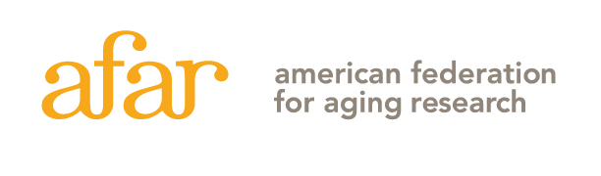
55 West 39th Street, 16th Floor, New York, NY 10018 (212) 703-9977

2017 New Investigator Award in Alzheimer’s Disease
Letter of Intent Instruction Sheet
Do not include with your Letter of Intent!

Please carefully read the application guidelines on the AFAR website, http://www.afar.org/research/funding/new-investigator-awards/ before completing this LOI.

INSTRUCTIONS: The Letter of Intent must be submitted to afarapplication@afar.org. The deadline for the letter of intent is March 6, 2017, at 5:00 p.m. EST. The file must be a single PDF, and must not exceed 5 MB. The file should be named as follows: “last name, first name”; for example “Smith, John.pdf”. No late submissions will be accepted.

Letter of Intent
Letters of intent will be evaluated on the relevance and significance of the proposed research and the qualifications of the applicant as outlined in the Guidelines.

Please submit the LOI in the order as listed on this page. Insert page number and applicant's name at the top of each page, and use a font that is not smaller than 11 pt with at least 1/2 inch margins on all sides. Any figures and essential references must be included on page 2.

The Letter of Intent (up to 7 pages) must consist of the following:

Page 1: Application Title Page, with abstract (include in space provided)
Page 2: In the following order, using the letter designation:

- Significance of this research to Alzheimer’s Disease and/or healthy brain aging
- Translational potential and relevance to Alzheimer’s disease and/or health brain aging
- Brief description of hypothesis
- List of Specific Aims
- Any figures and essential references (optional)

Pages 3-7: NIH-style biosketch for the applicant (up to 5 pages total) – applicants must be independent investigators with independent research space and must be no more than 10 years beyond start of postdoctoral research training as of July 1, 2017.

Applicants must have an Institutional Commitment Form completed by the Dean or Department Chair submitted separately via email to afarapplication@afar.org.

The Letters of Intent will be reviewed by a committee. Applicants will be notified by early April, and a subset of applicants will be invited to submit a full application by early May, 2017. AFAR will not provide reviewer critiques to any applicants at any review level.

THIS IS THE INSTRUCTION SHEET, DO NOT INCLUDE IT WITH YOUR LETTER OF INTENT. PLEASE FOLLOW THE INSTRUCTIONS CAREFULLY. LOIs THAT DO NOT FOLLOW THE REQUIRED FORMAT (FOR EXAMPLE, EXCEEDING PAGE LIMIT, MATERIALS IN WRONG ORDER) WILL BE ADMINISTRATIVELY ELIMINATED.
2017 New Investigator Award in Alzheimer’s Disease
Letter of Intent
[Title page: should be the first page of your application]

ONLY ONE LETTER OF INTENT PER INDIVIDUAL MAY BE SUBMITTED EACH YEAR.
Applicant Information  First Name: Last Name:  Degree(s):  Academic Title:  Institution:  Department:  Mailing Address:  City: State: Zip Code:  Country:  Phone: E-mail: | Project Title:

ABSTRACT: Provide a summary of your research proposal. Do not exceed space provided.

Key words:
Model system used for proposed research:

