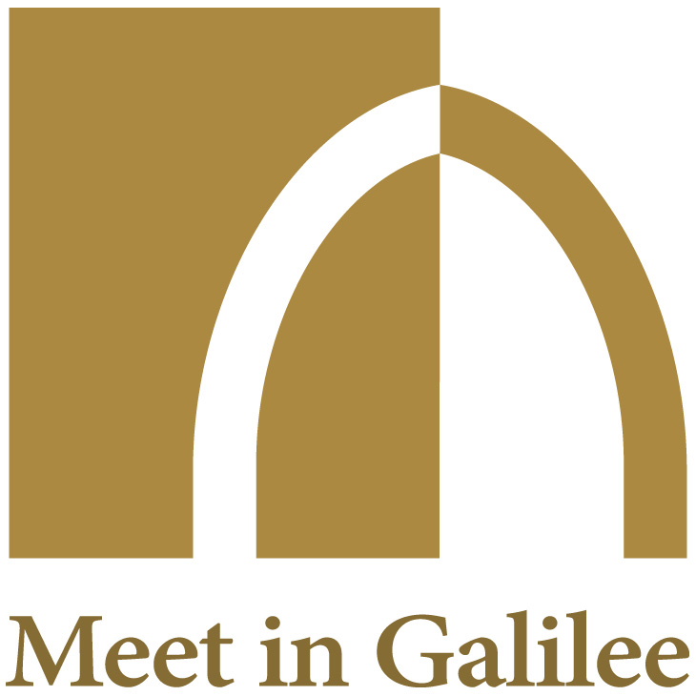

REGISTRATION FORM

INTERNATIONAL FORUM ON GENOMIC MEDICINE,

A NEW PARADIGM AND ITS IMPACT ON SOCIETY

Zikhron Yaacov, ELMA Hotel
July 16, 08:00 – 17:00

NAME :
FIRST NAME :
COMPANY / INSTITUTION :
TITLE :
ELECTRONIC ADDRESS :

TO BE SENT TO: muriel.haim@meetingalilee.com
Payment on: www.meetingalilee.com
Companies: 1200 shekels
Individuals: 300 shekels
Students: 150 shekels

